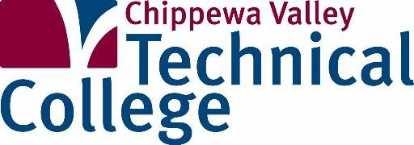**PRE-NURSING &**

**HEALTHCARE ACADEMY**

**DUAL CREDIT HIGH SCHOOL ACADEMY**

**…………………………………………………………………………………………………….**

CVTC and local high schools have partnered to offer incoming high school juniors and seniors who are interested in pursuing a career in pre-nursing and healthcare an opportunity to earn high school and college credit. Dual credit academies give high school students a chance to navigate their interests and career options to develop the most successful individualized career path. Credits successfully earned through this academy may be applied to CVTC’s technical degree programs and transfer to other universities. All of the academy courses listed below will be taught at the Osseo Mayo Hospital by CVTC instructorsduring the school year. Students will complete the prerequisites to the nursing program and be able to apply to the nursing waitlist after successfully completing this academy. Limited to 16 students in CNA.

|  |  |  |  |
| --- | --- | --- | --- |
| **Course Title** | **Course Dates** | **Times** | **Days** |
| 806-177 General Anatomy & Physiology  4 credits | September–December, 2022 | 8-10 am | M-F |
| 809-159 Abnormal Psychology  3 credits | TBD: September 2022, or January 2023 | 8–10 am | M-F |
| 806-179 Advanced Anatomy & Physiology  4 credits | January 2023 | 8–10 am | M–F |
| 543-300 Nursing Assistant (CNA)  2 credits | TBD: September 2022, 0r January 2023 | 8–10 am | M-F |

**GET STARTED!**

 To enroll in this dual credit opportunity or learn more, contact your High School counselor & apply on our website.

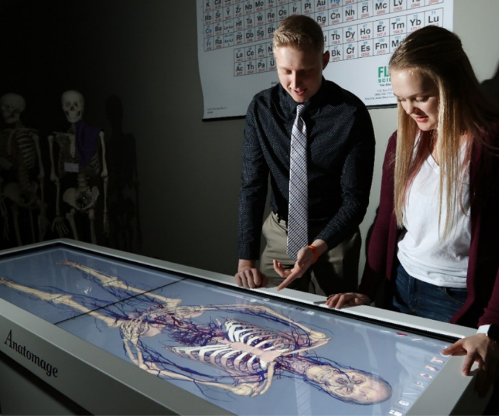

*Photo Credit: Dan Reiland*

**PRE-NURSING &**

**HEALTHCARE ACADEMY**

**DUAL CREDIT HIGH SCHOOL ACADEMY**

**…………………………………………………………………………………………………….**

This academy is designed to provide students the opportunity to earn a Certified Nursing Assistant (CNA) Technical Diploma as well as 13 credits in health-related coursework that apply to a number of CVTC programs.

**Pre-Nursing & Healthcare Academy Course Descriptions:**

**806-177 General Anatomy and Physiology** (4 Credits)  
Examines basic concepts of human anatomy and physiology as they relate to health sciences. Using a body systems approach, the course emphasizes the interrelationships between structure and function at the gross and microscopic levels of organization of the entire human body. It is intended to prepare health care professionals who need to apply basic concepts of anatomy and physiology to informed decision-making and professional communication with colleagues and patients.

**809-159 Abnormal Psychology** (3 Credits)

This course surveys the essential features, possible causes, and assessment and treatment of the various types of abnormal behavior from the viewpoint of the major theoretical perspectives in the field of abnormal psychology. Students will be introduced to the diagnosis system of the Diagnostic and Statistical Manual of Mental Disorders (DSM-IV). In addition, the history of the psychology of abnormality will be traced. Cultural and social perspectives in understanding and responding to abnormal behavior will be explored as well as current topics and issues within abnormal psychology.

**806-179 Advanced Anatomy and** **Physiology** (4 Credits)  
Advanced Anatomy and Physiology is the second semester in a two-semester sequence in which normal human anatomy and physiology are studied using a body systems approach with emphasis on the interrelationships between form and function at the gross and microscopic levels of organization. Instructional delivery within a classroom and laboratory setting. Experimentation within a science lab will include analysis of cellular metabolism, the individual components of body systems such as the nervous, neuro-muscular, cardiovascular, and urinary. Continued examination of homeostatic mechanisms and their relationship to fluid, electrolyte, acid-base balance, and blood. Integration of genetics to human reproduction and development are also included in this course.

**543-300 Certified Nursing Assistant (CNA)** (2 Credits)  
This 120-hour course is a combination lecture, lab, and clinical practice conducted in long-term care facilities.  It covers basic body function and structure, nutrition, nursing care procedures, and ethical and legal considerations. This course is recognized by the Wisconsin Department of Health Services as a nursing assistant training program. For successful completion you'll need to have access to a computer with an Internet hookup. This could be in your home, at a nearby library, at one of the CVTC branch campuses, or another location that is convenient for you. A Wisconsin criminal background check is required at the start of class.

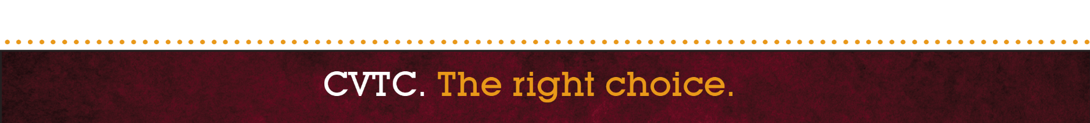**CNA State Attendance Policy**Students must comply with the Wisconsin DHS required 120 training hours for CNA.  Students are allowed to miss two classes but are required to make up the missed time.  Failure to make up missed time will result in course failure.  If a third class or clinical session is missed, the student will fail the course.  Clinical time must be made up at the clinical site and not with a written assignment.  Students may attend a lecture, lab, or clinical session with another instructor to avoid grading deductions. Students are responsible to coordinate make up times with their instructor.  In case of documented illness or emergency, a waiver may be granted.

